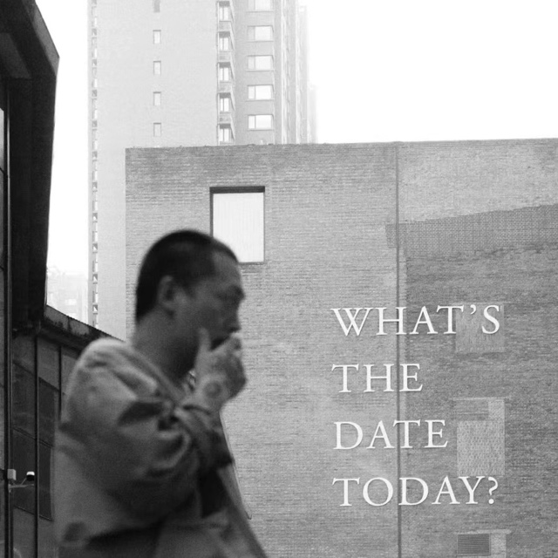
李怒，毕业于英国皇家艺术学院雕塑系，获硕士学位，2015年荣获英国皇家雕塑家协会Bursary大奖。英国皇家雕塑家协会成员。现生活和工作于北京。
李怒的创作植根于日常之中，将客观真实性之下的自我经历和主观化感受作为创作媒介，表现了对于社会大环境的普遍性感知、以及个体的情绪波动和群体在宏观社会演变中的精神状态。他关注偶然、突发以及当下状态的真实性存在，反对形式和技巧，摈弃视觉上的单调以及现代主义后期艺术家创作上连贯性、策略性和风格化的创作范式，探索装置艺术、当代雕塑、实验影像以及现场艺术等的各种可能性。他颠覆纪实与虚构、再现和抽象之间的感知界限来探索和实践当代艺术的语言。他把一切事物视为具有生命感知的存在，在看似信手拈来的材料运用和不择手段的艺术表达之中，是他敏锐而丰富的艺术语言。他的作品有着强烈的扩张力和穿透力，既观念又感官，既直白又隐晦，既诗性又现实，并具有某种隐喻的、尖锐的、幽默的、诗性的和戏剧性特质。他的作品通常是复杂的，并且包含着多重含义。
Li Nu graduated with an MA in Sculpture from Royal College of Art. He won the 2015 RBS (Royal British Society of Sculptors) Bursary Awards, and as a member of RBS, lives and works in Beijing.
Li Nu roots in everyday life. He subverts the perceived boundaries between documentary and fiction, representation and abstraction to explore and achieve a poetic language in art. Through capturing the details of everyday life, he aims to reflect the individual’s mood swings and the menials state of population in the evolution of macro-society. The apparently unpromising materials of everyday life are transformed into something metaphorical, poignant, humorous, poetic and dramatic, challenging us to question our received experiences about life and see the world afresh. The concept that he wants to express is never what you have seen. It is always wandering between void and solid.

